RESOLUTION NO.__________

RE: CERTIFICATE OF APPROPRIATENESS UNDER THE
PROVISIONS OF THE ACT OF THE PENNSYLVANIA
LEGISLATURE 1961, JUNE 13, P.L. 282 (53
SECTION 8004) AND BETHLEHEM ORDINANCE NO.
3952 AS AMENDED.

WHEREAS, it is proposed to install vinyl window lettering – Bone Appetit Dog Barkery at 444 Main St.

NOW, THEREFORE, BE IT RESOLVED by the Council of the City of Bethlehem that a Certificate of Appropriateness is hereby granted for the proposal.

Sponsored by: (s)

(s)

ADOPTED BY COUNCIL THIS DAY OF

(s)
President of Council

ATTEST:

(s)
City Clerk

HISTORICAL & ARCHITECTURAL REVIEW BOARD

The applicant is proposing to install vinyl window lettering – Bone Appetit Dog Barkery at 444 Main St.
APPLICATION #1:

Moravian Book Shop
444 Main St.
Bethlehem, PA 18018

OWNER:

__________________________________________________________________________

The Board upon motion by Phil Roeder and seconded by Marsha Fritz adopted the proposal that City Council issue a Certificate of Appropriateness for the following:

- Install vinyl logo and lettering on the storefront window.

- Lettering should say Bone Appetit Dog Barkery.

- Logo and lettering should be in “Almond” color.

4. The motion was unanimously approved.

__________________________________________________________________________

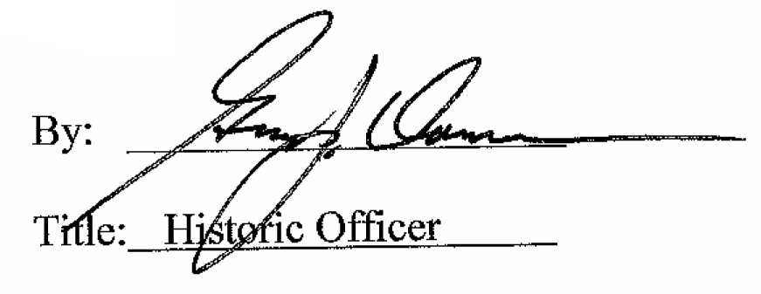

Date of Meeting: May 3, 2017

